[WI00776598 - IT (TS) Register GUI for Italy](edient:Command=ShowEditForm&ControllerID=WorkItem&BusinessEntityPK=417141aa-a6aa-4b56-9d15-9df4978edcaf&VersionNumber=24.8.14.72&Domain=wtg.zone&Instance=ediProd&Hash=%2bPKNY9deg9ebiYr1xDiCwZTrfllCWn8eT)

# Summary

All required fields to manage Register reports for TS in Italy are managed in GUI

# Background General Concepts

##### Register's purposes are

1. collect each MRN (Bill) + Item inward data from G4 messages in Temporary Storage UCC to TS Register
2. for each line, collect outward transactions taken from related Invoice Line and Entry Instructions Previous Documents in Declaration Jobs or from related Goods Items Previous Documents in NCTS Departures
3. allow the user to enter Adjustment transactions for each MRN (Bill) + Item
4. print the report with open or closed MRNs (Bill) + Items, with the detail of their transactions (each inward movement is considered closed when the sum of both packages and gross weight in its transactions are zero. Note that bulk goods are entered with zero packages and re-packaging is not allowed in TS)
5. print a report with a chronological list of transactions
6. print a report with stock per MRN, Item
7. Search screen with MRNs, Bills, Items, Transactions, Container ID and other references

Design process  
We will follow the list below, managed in the NCN WIs, of which this WI is the first, i.e., the master:

1) check the existing report, search screen and GUI of the French version, already in place.  
Also compare it with the Spanish one

2) start to list, on an excel sheet, all fields provided to print on the current legacy product's Italian report

3) compare each field with those in the French CW report

4) verify that all the fields required for Italy are in the Register tables:

CusTempStorageRegHeader  
 CusTempStorageRegLine  
 CusTempStorageRegLineItem  
 CusTempStorageRegLineItemPivot  
 CusTempStorageRegLineTransaction  
 CusCodeData

5) verify that all the fields needed for Italy are in the French GUI of the Register

6) indicate the correct captions for each field and give evidence of them with images

7) add missing fields/captions, if any, and change their nature when needed

8) correlate the Register fields with those coming from TS-UCC, Customs Declaration and NCTS Departure.

This will be followed by:

(a) setting up the Search Screen IT filter fields.

(b) creation of events to add data to Register tables

(c) creation of reports

Basic Concepts  
- Every Register Header will be created from a TS Bill with its MRN as reference  
- Register Items (Lines) will be created from each TS Item under its Bill, A3 Number received by Customs is a key for the Owner  
- The first transaction under a Register Line will be created with type OBL (Open Balance) representing incoming goods for the line, with its MRN+item No. as reference  
  
Reference

TS Register as included in the FR guide [WI00618555 - FR - Content - Temporary Storage Register](edient:Command=ShowEditForm&ControllerID=WorkItem&BusinessEntityPK=adebad55-fede-4b37-bedf-18ecd73e9109&VersionNumber=24.7.16.16&Domain=wtg.zone&Instance=ediProd&Hash=%2b2A8SFIhRwg%2b%2bC9GPu7nVPAoX6ZM3QX%2bP)

Italian legacy reports collection [WI00704484 - IT (TS) stampe registri a partite](edient:Command=ShowEditForm&ControllerID=WorkItem&BusinessEntityPK=691ce1b8-f557-4957-ae02-b7c050b5b0ae&VersionNumber=24.8.13.52&Domain=wtg.zone&Instance=ediProd&Hash=%2baMNrAvthov9de45RM%2fjglbF4%2bxpF2H6J)

##### Fields Mapping

[WI00776598 - IT (TS) Register GUI for Italy.xlsx](https://wisetechglobal.sharepoint.com/:x:/r/sites/DevelopmentCustomsTeam/Shared%20Documents/IT/Work%20Items/TS_Declarations/WI00776598%20-%20IT%20(TS)%20Register%20GUI%20for%20Italy/WI00776598%20-%20IT%20(TS)%20Register%20GUI%20for%20Italy.xlsx?d=waae5d8e4120b4364aa3713fa39372b2c&csf=1&web=1&e=iT4rWV)

The only field to change, after investigation, is gross weight number of decimals from 5 to 6 to align with G4 message

##### French print Example

##### Italian legacy report

‘Registro partitario ridotto’

Sample message G4 esito from IT Customs:

# Implementation

Part.1 – Change Decimals in Gross Weight  
  
Change CusTempStorageRegLineTransaction.SRT_GrossWeight decimals from 5 to 6 in DB

Part.2 – GUI

Only for IT  
  
On the following menu item  
  
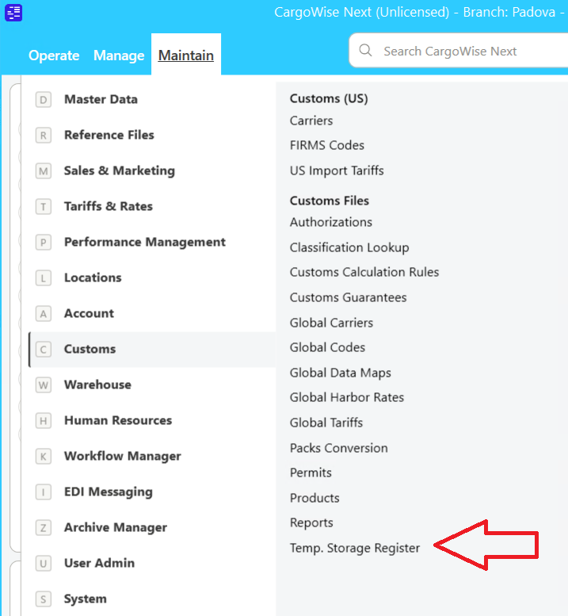

create the following screen  
  
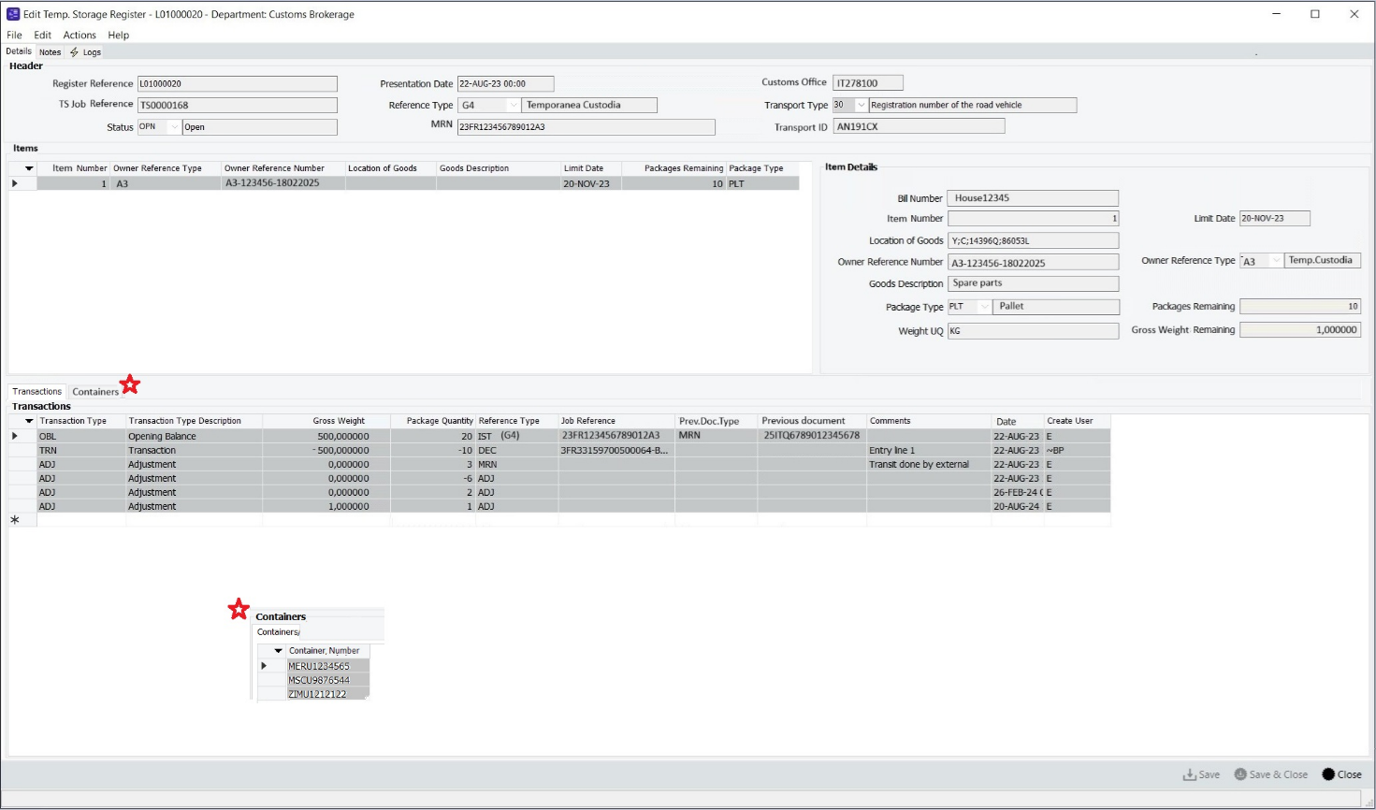

For fields list see the sheet ‘**Field Mapping TS Register GUI’** in <https://wisetechglobal.sharepoint.com/:x:/r/sites/DevelopmentCustomsTeam/Shared%20Documents/IT/Work%20Items/TS_Declarations/WI00776598%20-%20IT%20(TS)%20Register%20GUI%20for%20Italy/WI00776598%20-%20IT%20(TS)%20Register%20GUI%20for%20Italy.xlsx?d=waae5d8e4120b4364aa3713fa39372b2c&csf=1&web=1&e=iT4rWV>

All fields must be readonly

Fields in Transactions type ADJ will be enabled in [WI00877330 - IT (TS) Register - Manual Adjustments on Transactions](edient:Command=ShowEditForm&ControllerID=WorkItem&BusinessEntityPK=701771db-c5db-4b46-899e-ee1a97c1bb5c&VersionNumber=25.3.3.20&Domain=wtg.zone&Instance=ediProd&Hash=%2bACh4XuTp%2bXtV6f%2bFF2xVNS8VCP1LO15o)

Validations will be applied on [WI00877324 - IT (TS) Register - Validation transactions fields in GUI](edient:Command=ShowEditForm&ControllerID=WorkItem&BusinessEntityPK=f4759b58-7158-4d03-8fb8-ae2b47915fd6&VersionNumber=25.3.3.20&Domain=wtg.zone&Instance=ediProd&Hash=%2bg5JDw7XGW7JuOqirziBvhVs%2bonE622f1)Note for Chunkers  
Consider starting from the French version of TS Register GUI to build the Italian one

# Technical Specifications

Part.1 – Change Decimals in Gross Weight

##### Workflow: Schema Change

Do the schema change. Data transformation are required to address the rare scenario where clients have entered CusTempStorageRegLineTransaction.SRT_GrossWeight with 14 digits. After the schema change, only 13 digits will be available in the integer part.

Similar transformations have been implemented in

[WI00694801 - IT (TS) Change DB fields for quantities to 6 decimals](https://svc-ediprod.wtg.zone/Services/link/ShowEditForm/NewWorkItem/2e4e9aa7-5fdd-4290-8a42-6ea08f65fa74)

[WI00647235 - EU (21IMP+21EXP) All quantity fields in Invoice Lines have 6 decimals](https://svc-ediprod.wtg.zone/Services/link/ShowEditForm/NewWorkItem/4b402bdf-f288-4b86-9def-8532f674507c)

[WI00699680 - EU - NCTS5 Dep - Add third and fourth qty to calculate taxes](https://svc-ediprod.wtg.zone/Services/link/ShowEditForm/NewWorkItem/c217084b-1272-4ef9-bfeb-d03ccfebf5c0)

Part.2 – GUI

##### Workflow: GUI

Activate the “Temp. Storage Register” module for IT.

Implement the code in IT.TemporaryStorage.sln

See how FR activated it [Pull request 224473: WI00711789 - EU - PNTS - enable menu option 'Temp. Storage Register'-version3 - Repos](https://devops.wisetechglobal.com/wtg/CargoWise/_git/Dev/pullrequest/224473)

Scaffold the controller and module.

The form to inherit from and customize is C:\git\wtg\CargoWise\Dev\Enterprise\Product\Operations\Customs\EFTA\TemporaryStorageRegister\GUI\SumARegisterForm.cs

Reach out to the chunker if the scaffolding and customization is not straightforward so that we can discuss and chunk it further.

# EU Design and Product Review

|  |  |  |
| --- | --- | --- |
|  | **Choice** | **Note** |
| Necessary |  |  |
| Not necessary | XXX | It is only for Italy |
| Other |  |  |

# Update Note

|  |  |  |
| --- | --- | --- |
|  | **Choice** | **Note** |
| Necessary |  |  |
| Not necessary | XXX | This a new module, a ‘How To..’ document will be created |
| Other |  |  |